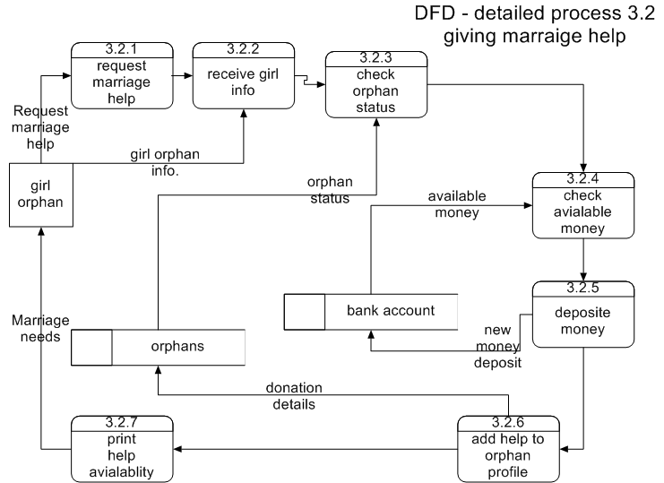

*Process 3.1.3 check orphans status*

*IF orphan is really in need*

*Continue request procedures*

*Else*

*Refuse help request*

*End Process*

*Process 3.1.4 check money availability*

*IF money is available*

*Accept this help request*

*Else*

*Refuse money request*

*End Process*

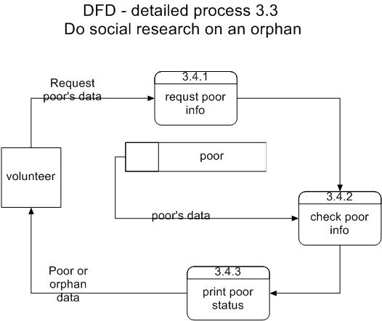

**,g**

**Detailed DFDs for the marriage and orphans helping sub-system with their descriptions:**

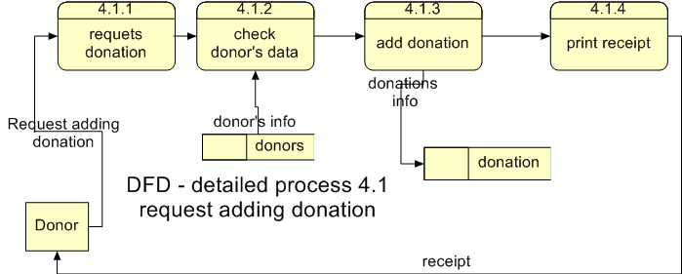

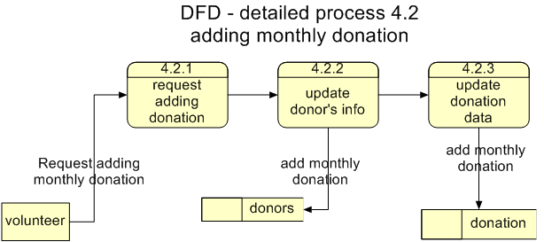

*Process 4.1.2 check donor’s data*

*IF donor is registered*

*Accept donation*

*Else*

*Ask donor to register*

*End Process*

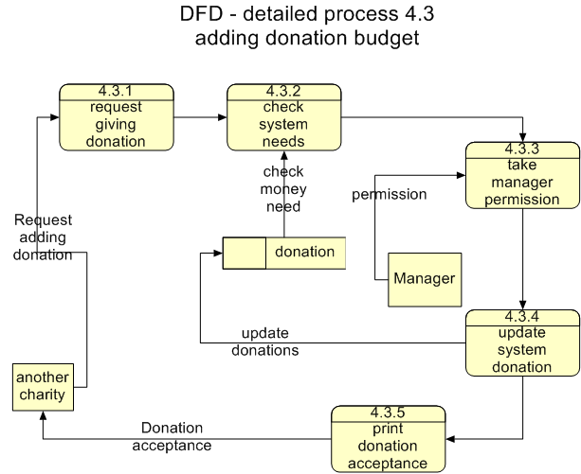

*Process 4.3.3 check manager permission*

*IF manager accepts donation*

*Accept this donation*

*Else*

*Refuse donation*

*End Process*

*Process 4.3.2 check system needs*

*IF system has needs*

*Ask for manager permission*

*Else*

*Refuse help*

*End Process*

**Chapter 3**